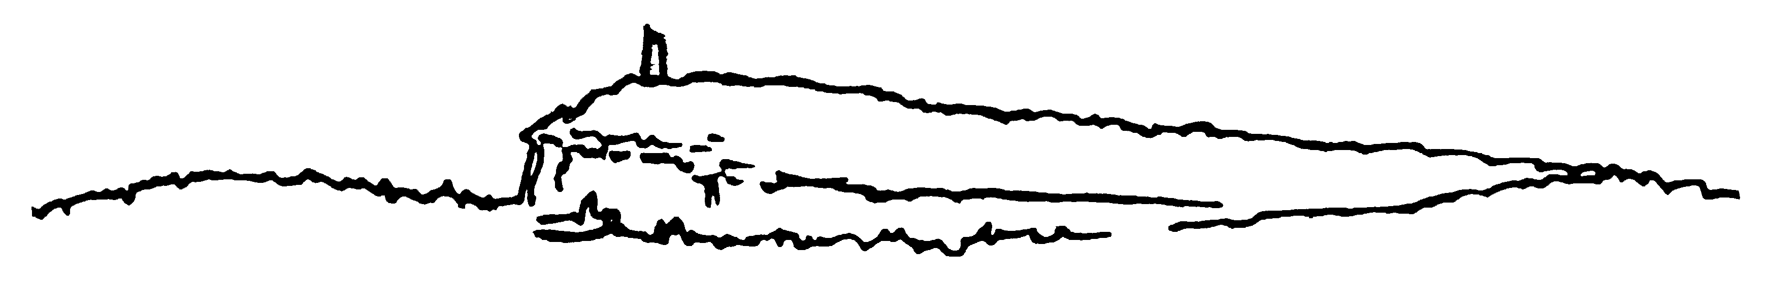

New Paltz Central High School

New Paltz Central School District. 196 Main Street, New Paltz, NY 12561

Tel. (845) 256-4100. Fax (845) 256-4109. E-mail: npchs@newpaltz.k12.ny.us
Barbara Clinton Tara Ryba
Principal Assistant Principal
FIELD TRIP PERMISSION FORM

Date: June 14, 2018

The Peer Educators will be teaching the “Transition to High School” lesson to all Middle School 8th grade Health classes on Tuesday, June 19th and Wednesday, June 20th, 2018. Students are responsible for their own transportation to and from the Middle School on those dates. Students will not be allowed to drive or to receive a ride from a student who is driving without parent consent/permission. Please read, sign, and submit this permission slip to Mrs. Magnetico OR the Main Office ASAP.

_____________________________________ has my permission to go with/ride with
Student’s Name
________________________________________ on a field trip to New Paltz Middle School to teach 8th grade Health students the “Transition to High School” lesson. Students will meet on Tuesday, June 19th at the Middle School main entrance at 7:50am. Classes begin at the M.S. at 8:00am on Tuesday morning and finish by 2:35pm.
On Wednesday, June 20th students will meet at the Middle School main entrance at 8:15am. Classes will begin at 8:40am on Wednesday and finish by 2:35pm.

Thank you for supporting your child in their development of leadership and social skills as they play an integral role in this program.

_______________________________ Parent/ Guardian Signature
Sincerely,

Shannan Magnetico - Health Teacher, NPHS

